CMPUT 302 W14

Project Design Milestone

Feb 14th, 2014

Augmented Pen & Paper Interface

Team 4

Group Name: Pen & Paper

Group Members: Ashley Dawn Brown, James Cadek, Gerald Manweiler, Eddie Tai, Yi Zou

Division of Labour:

Division of labour is fluid and determined by each team member’s current academic workload, unique skill sets, interests, and project requirements & deadlines. Workload will be managed by consensus and twice weekly meetings. Workload will be communicated via meetings, email, Trello and our [Github Project Wiki](https://github.com/CMPUT302W14T04/Interface/wiki). Project tasks that lend themselves to one team member being the primary will always be supported by team consensus. All team members have design input, but one team member will be responsible for final prototype copy. Project management will generally be handled by one team member and documentation by another. There will be one primary programmer, but all team members will contribute to the code base. One team member will lead the experimental testing methodology design, but all members will contribute.

Project Description:

The main objective of this project is to capture and digitize graphical annotation on a paper geographic information system/land use/topographical maps, and be synchronized with relevant audio and video information in a portable fashion.

The project source is Trevor Wiens of [Apropos Information Systems](http://aproposinfosystems.com/). Trevor hopes to use this product with his main product [LOUIS Heritage](http://louistk.ca/EN/heritage-home/), a tool to help indigenous people in preserving, protecting and promoting their traditional knowledge and values. LOUIS Heritage allows text, maps and media files to be stored and used together.

The project is scientifically interesting because a portable geographic map annotation digital capture system integrated with [Natural Language Processing coding](http://louistk.ca/EN/heritage-home/heritage-features/), and based on tracking an infrared source, and does not currently exist. Current partial solutions rely on a [projector](http://en.wikipedia.org/wiki/Interactive_whiteboard#Operation_of_a_portable_ultrasonic.2C_IR_pen-based_interactive_whiteboard) or a uniquely patterned paper and a digital pen (such as [anoto pen & paper](http://www.anoto.com/lng/en/mode/sublist/documentId/1150/pid/480/)) to save written content to a computer. This project aims to remove the need of these requirements for the capture system, which may be beneficial and inspirational to many other scientific developments.

The functionality of the system will be tracking and geo-referencing an infrared dot from a pen on a paper map. First, the map will be calibrated. An audio/video recording will capture the entire session and provide a date/time stamp for cross referencing. When the system picks up infrared signal from the pen, the system will record the coordinates from the map and the date/time stamp of the infrared signal. Wiimotes will be used as the infrared sensors.

The software interface will feature a main screen with menu bar that lets a user enter basic session info on a laptop (map unique identifier, interviewer(s), interviewee(s), date & time), an interface to calibrate the infrared pen to the land use map, an interface to give real time feedback of infrared coordinate capture points in relation to location on the land use map, and menu to control video/audio recording of the session.

Evaluation of Interface/Experimental Testing Methodology:

The main forms of evaluation of this project will be:

* Ease of use and start up time for preparing a session
* The motion tracking resolution (our client specified a 1.5 mm accuracy goal)
* The versatility of hardware positioning
* Ease and accuracy of calibration
* Possible Experimental Methodology
  + Trace marking on a paper map with IR pen, digitize annotated map, and compare captured geo-referenced IR coordinates with paper map annotation geographic coordinates. Test annotations will be a point, a line, and a rectangle
  + IR pen coordinate marking on paper map versus Google maps coordinate marking time trial
  + IR resolution of 2 wii remotes versus 4 wii remotes

Client Need Analysis:

* Portability, ease of use and the ability to use paper maps are the utmost priority for the client
* The client wants to reduce manpower costs from a multi-person interview team to a one person interview team.
* The client wants to digitally capture and geo-reference annotations made on a paper map. Resolution of 1.5 mm required on 1:50000 scale maps.
* The client wants digitized map feedback of the IR capture.
* The client wants to verbally anchor map annotation with audio recording of unique feature id of map annotation. This will be used by the Natural Language Processing (NLP) functionality of the client’s product LOUIS Heritage (Land Occupancy and Use Information System) to integrate map annotation. The audio anchoring will be done by timestamp matching to the IR coordinates capture.
* The client needs map/audio/video session data saved in a format compatible with the client’s product LOUIS Heritage.
* The client wants a single video/audio recording of the session.
* The client has specified that the system should work with any operating systems.
* The client specified a maximum map size of 4 feet by 6 feet.
* The client a maximum map bearing surface of a conference room table.

Constraint Analysis:

* All hardware and software setup for an interview session must be done by the interviewer. Therefore, set up time should be minimal.
* Furthermore, the interviewer is not an IT professional. Therefore, some, but not extensive, user training will be required. The training would consist of how to setup, calibrate and use the infrared tracking hardware, and how to record audio/video.
* Further corollary, the physical weight and size of the hardware should be in order of 2 cubic feet and 5 pounds weight.
* Due to time constraints in development, this program will only be supported for Windows initially. If time allows then we will develop support for other operating systems.
* The largest map feasible for use is 24 inches by 36 inches
* The smallest map bearing surface is an average kitchen table.
* We will capture all IR annotations but will not be able to do optical character recognition.

Paper Prototypes:

The computer interface is based on a utilizing three major tabs of “Session Info,” “Map Calibration” and “Recording.” Each tab is responsible for an important aspect requested by the client, as mentioned by the project description. The first version of the prototype, based on the first meeting with the client, is shown below as the first 3 images. The hardware setup is also demonstrated in the paper prototype for “Map Calibration” in terms of usage for the wiimotes.

After the second meeting with the client, some questions have been clarified regarding a need for a video feedback. The client also expressed that a continuous audio/video recording is preferred for each session over spliced audio record whenever a mark with the IR pen is made. The interface is modified to suit these needs. Most of the changes are in the “Recording” tab. Many aspects from the first prototype are carried over. Any properties mentioned in the first prototype are also present in this second prototype, unless the feature is explicitly mentioned to be dropped in the annotations. The 4th to 6th images shown here are the version 2 paper prototypes.

In the “Map Calibration” drawing for the 2nd version of the prototypes, it shows the potential setup using 4 wii remotes instead of 2 wii remotes as well.

Not shown in the paper drawings are the wii remotes. The wii remotes will emit blue lights if it can successfully connect with the computer through Bluetooth. If the wii remotes are moved significantly out of place, through the wii remotes’ gyroscope, the program will be interrupted and users will be prompted for a calibration again.

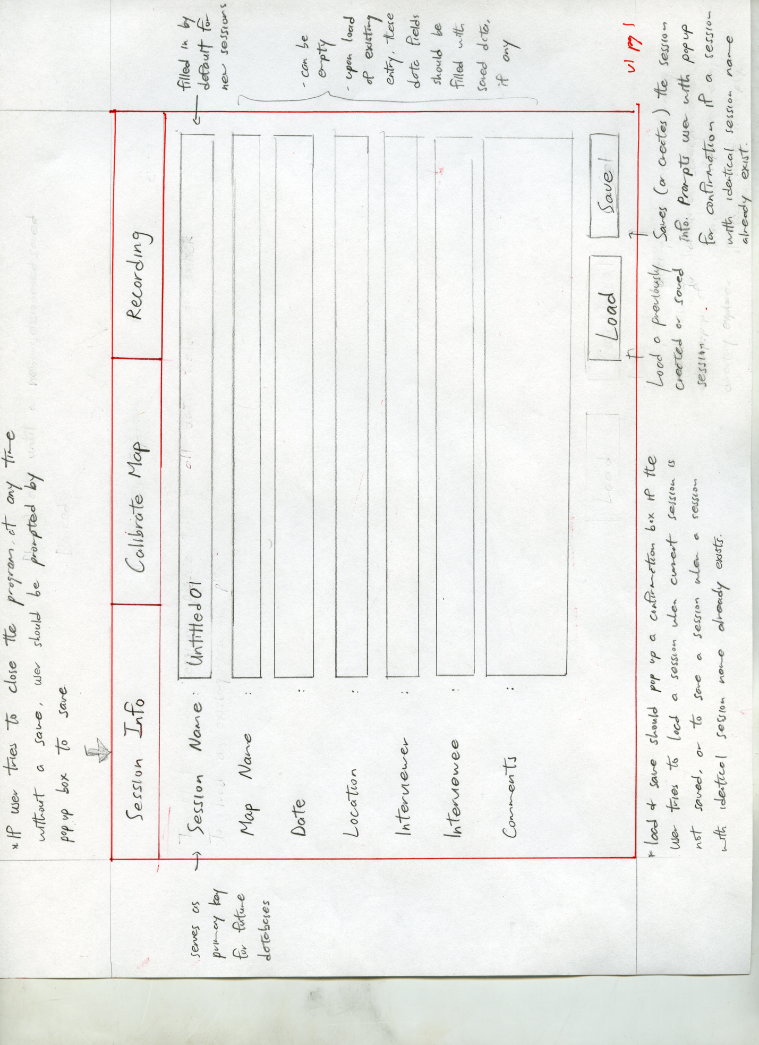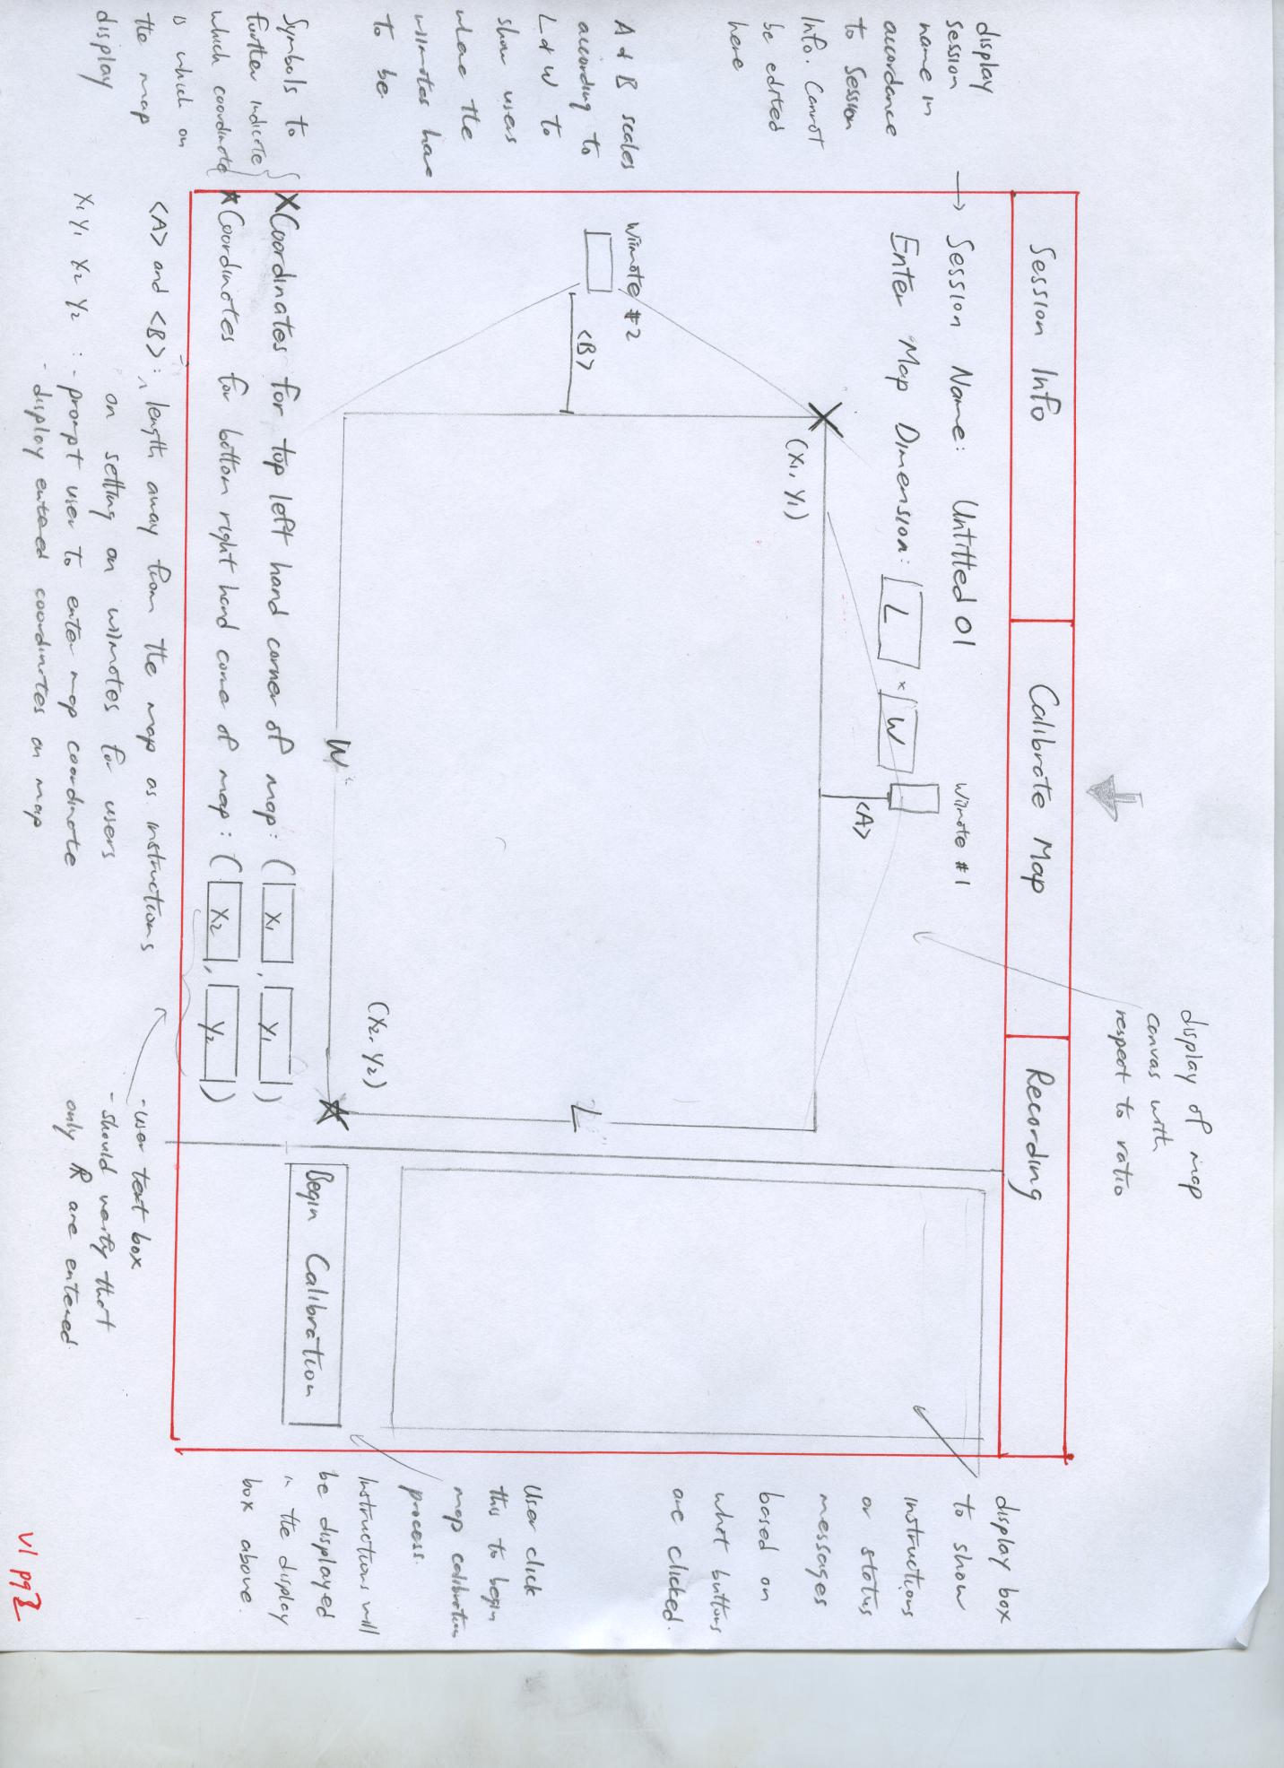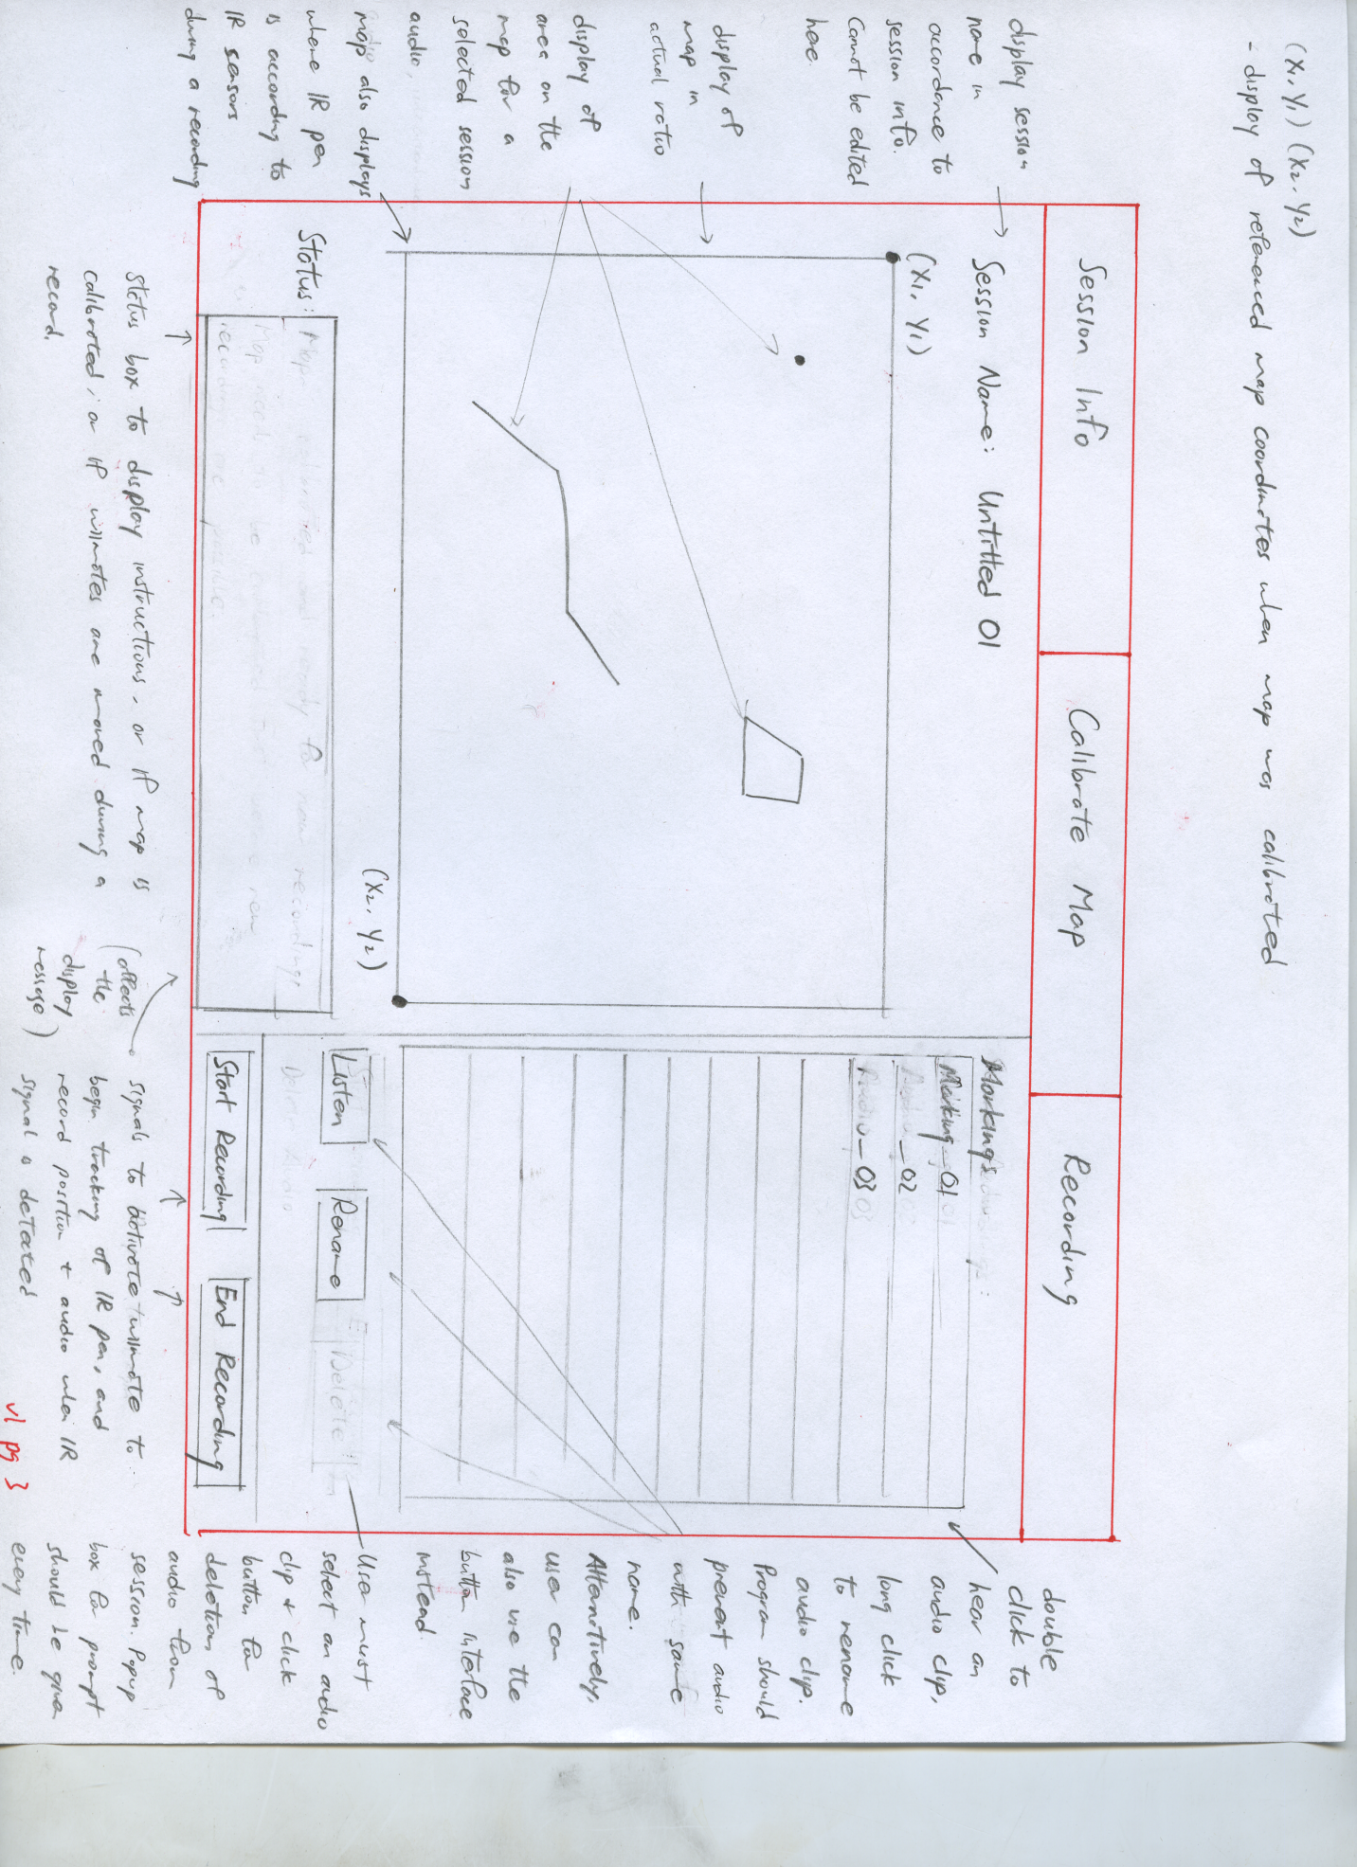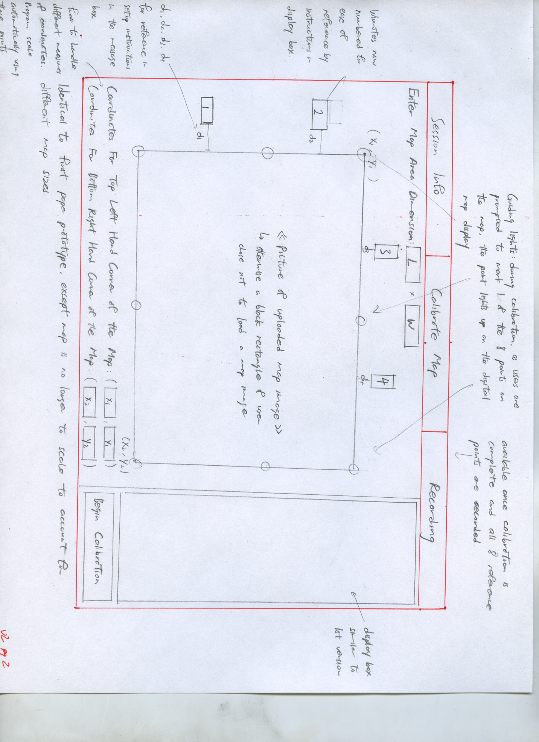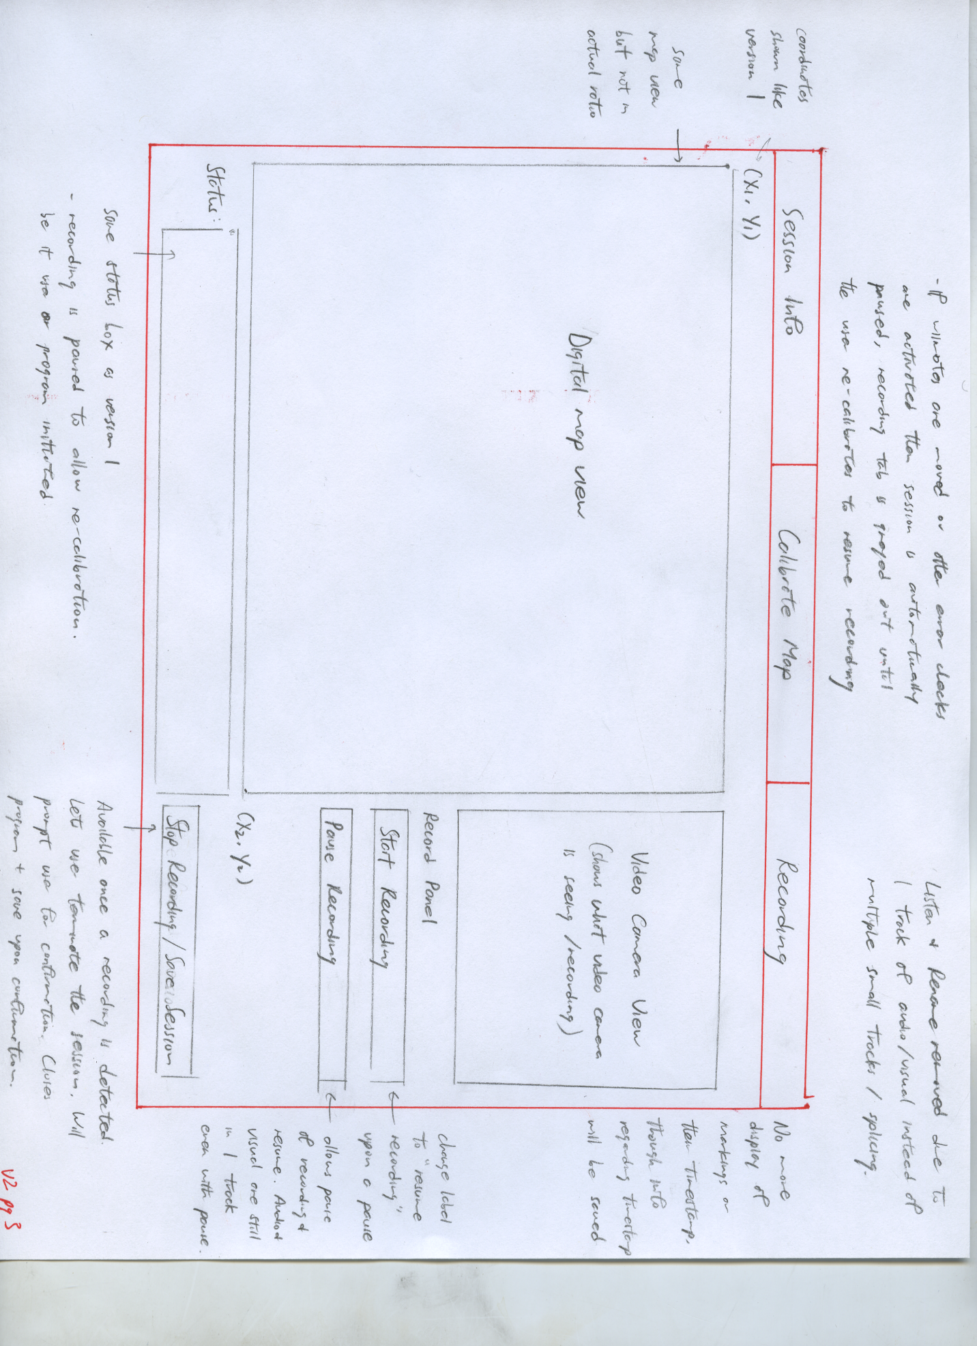

Heuristic Analysis:

A heuristic analysis will be conducted per the guidelines suggested by Jakob Neilsen. The analysis will be done by 3 team members, taking the average of the ratings.

<http://www.nngroup.com/articles/how-to-conduct-a-heuristic-evaluation/>

<http://www.nngroup.com/articles/ten-usability-heuristics/>

<http://www.nngroup.com/articles/how-to-rate-the-severity-of-usability-problems/>

*The following 0 to 4 rating scale will be used to rate the severity of usability problems:*

**0** = I don't agree that this is a usability problem at all   
**1** = Cosmetic problem only: need not be fixed unless extra time is available on project   
**2** = Minor usability problem: fixing this should be given low priority   
**3** = Major usability problem: important to fix, so should be given high priority   
**4** = Usability catastrophe: imperative to fix this before product can be released

*The following 10 heursitics will be used:*

**Visibility of system status**

The system should always keep users informed about what is going on, through appropriate feedback within reasonable time.

**Match between system and the real world**

The system should speak the users' language, with words, phrases and concepts familiar to the user, rather than system-oriented terms. Follow real-world conventions, making information appear in a natural and logical order.

**User control and freedom**

Users often choose system functions by mistake and will need a clearly marked "emergency exit" to leave the unwanted state without having to go through an extended dialogue. Support undo and redo.

**Consistency and standards**

Users should not have to wonder whether different words, situations, or actions mean the same thing. Follow platform conventions.

**Error prevention**

Even better than good error messages is a careful design which prevents a problem from occurring in the first place. Either eliminate error-prone conditions or check for them and present users with a confirmation option before they commit to the action.

**Recognition rather than recall**

Minimize the user's memory load by making objects, actions, and options visible. The user should not have to remember information from one part of the dialogue to another. Instructions for use of the system should be visible or easily retrievable whenever appropriate.

**Flexibility and efficiency of use**

Accelerators -- unseen by the novice user -- may often speed up the interaction for the expert user such that the system can cater to both inexperienced and experienced users. Allow users to tailor frequent actions.

**Aesthetic and minimalist design**

Dialogues should not contain information which is irrelevant or rarely needed. Every extra unit of information in a dialogue competes with the relevant units of information and diminishes their relative visibility.

**Help users recognize, diagnose, and recover from errors**

Error messages should be expressed in plain language (no codes), precisely indicate the problem, and constructively suggest a solution.

**Help and documentation**

Even though it is better if the system can be used without documentation, it may be necessary to provide help and documentation. Any such information should be easy to search, focused on the user's task, list concrete steps to be carried out, and not be too large.

Scenarios:

*Scenario One: Georeferencing Calibration of Map*

To calibrate a map for use, the map must be securely affixed to a flat surface. The user must have the dimensions of the map image and input them to the system. The user will then input the map coordinate system and geographic coordinates of the map corners into the system. The system will compute the geometry and give the user the distance measurements to place the infrared sensors in relation to the map. The user wil place the infrared sensors at the specified positions. The user will then calibrate the system to the corners of the map with the infrared pen. The system will give graphical feedback to the user showing an outline of the map and the captured infrared calibration points.

*Hierarchal Task Analysis:*

1. Georeferencing Calibration of Map
   1. Secure map to flat surface
   2. Measure map image dimensions
   3. Input map image dimensions into system
   4. Input map coordinate system
   5. Input map corner coordinates
   6. Compute infrared sensor positions geometry in relation to map image
   7. Place infrared sensors at specified positions
   8. Turn on infrared sensors
   9. Mark corners of map with infrared pen
   10. Verify accuracy of corner calibration on map graphical user interface image

Plan 0: do 1 or 2 in any order before doing 3-4-5 in any order then do 6-7-8-9-10 in order

*Scenario Two: Land Usage Interview*

The interviewer will start the audio/video recording of the session. As the interviewee answers questions about land use, the interviewer will say what Natural Language Processing land usage code is being annotated on the map and make the graphic and textual annotations with the infrared pen. The system will record each captured infrared coordinates and translate them into geographic coordinates for the map. The system will also capture a timestamp for each infrared capture. When the interview is over, the interviewer will stop the audio/video recording.

*Hierarchal Task Analysis:*

1. Land Usage Interview
   1. Start audio/video recording
   2. Ask interview questions
   3. Speak land usage codes corresponding to land usage answers
   4. Use infrared pen to capture graphic land usage annotation
   5. Save geographical coordinates and timestamp
   6. Translate graphic annotation coordinates to geographical coordinates
   7. Use infrared pen to capture textual land usage annotation
   8. Save textual land usage code annotation map coordinates and timestamp
   9. Verify accuracy of infrared capture on map graphical user interface image
   10. Stop audio/video recording

Plan 0: do 1-2-3 in order

Plan 2: do 2.1-2.2-2.3-2.4-2.5-2.6-2.7 in order for each question

Need For Material:

* Hardware
  + Laptop
  + Wii remotes
  + Broadcom 2046 Bluetooth 2.1+EDR USB Dongle with First Connect
  + Infrared pen, 940nm frequency
  + Paper land use map (22” by 34” on average)
  + USB video camera + tripod for video camera
  + Measuring Tape
  + Tape, or other means to hold the land use map in place
* Software
  + Wiiusej API (wii remote java interface)
  + Windows 7
  + Java Media Framework API (JMP, for video capturing)
  + Java and IDE suitable for coding with Java, such as Eclipse and/or Netbeans

Sources:

https://github.com/CMPUT302W14T04/Interface/wiki

http://aproposinfosystems.com/

http://louistk.ca/EN/heritage-home/

http://louistk.ca/EN/heritage-home/heritage-features/

http://en.wikipedia.org/wiki/Interactive_whiteboard#Operation_of_a_portable_ultrasonic.2C_IR_pen-based_interactive_whiteboard

http://www.anoto.com/lng/en/mode/sublist/documentId/1150/pid/480/

http://www.nngroup.com/articles/how-to-conduct-a-heuristic-evaluation/

http://www.nngroup.com/articles/ten-usability-heuristics/

http://www.nngroup.com/articles/how-to-rate-the-severity-of-usability-problems/